# ASSIGNMENT3

**Question 1:** Display a upload file using flask.

# PROGRAM

**Resume.py**

from flask import Flask, render_template, request from werkzeug import secure_filename

app = Flask( name )

@app.route('/upload') def upload_file():

return render_template('upload.html')

@app.route('/uploader', methods = ['GET', 'POST']) def upload_file():

if request.method == 'POST':

f = request.files['file'] f.save(secure_filename(f.filename)) return 'file uploaded successfully'

if name == ' main ':

app.run(debug = True)

##### upload.html

<html>

<body>

<form action = "http://localhost:5000/uploader" method = "POST" enctype = "multipart/form-data">

<input type = "file" name = "file" />

<input type = "submit"/>

</form>

</body>

</html>

##### OUTPUT:



**Question 2:** Display a registrarion form using flask

**PROGRAM:**

**script.py**

from flask import * app = Flask( name )

@app.route('/') def customer():

return render_template('customer.html')

@app.route('/success',methods = ['POST', 'GET']) def print_data():

if request.method == 'POST':

result = request.form

return render_template("result_data.html",result = result)

if name == ' main ':

app.run(debug = True)

##### customer.html

<html>

<body>

<h3>Register the customer, fill the following form.</h3>

<form action = "http://localhost:5000/success" method = "POST">

<p>Name <input type = "text" name = "name" /></p>

<p>Email <input type = "email" name = "email" /></p>

<p>Contact <input type = "text" name = "contact" /></p>

<p>Pin code <input type ="text" name = "pin" /></p>

<p><input type = "submit" value = "submit" /></p>

</form>

</body>

</html>

##### Resultdata.html

<!doctype html>

<html>

<body>

<p><strong>Thanks for the registration. Confirm your details</strong></p>

<table border = 1>

{% for key, value in result.items() %}

<tr>

<th> {{ key }} </th>

<td> {{ value }} </td>

</tr>

{% endfor %}

</table>

</body>

</html>

##### OUTPUT:

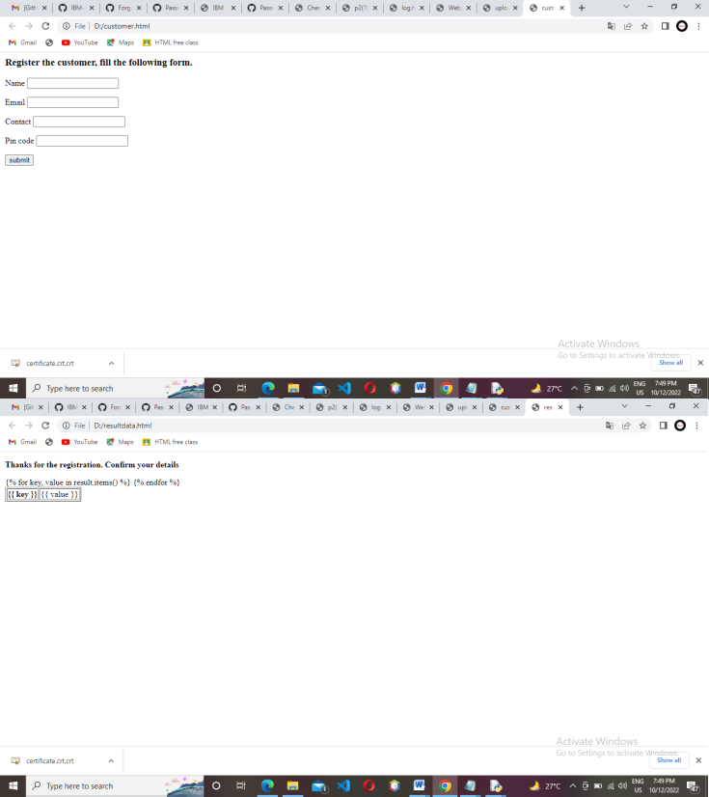

**QUESTION 3:** Login page

## PROGRAM

### assign5.py

from flask import Flask, render_template, request, redirect, url_for , session import ibm_db

import re @app.route('/') def index():

return render_template('index.html') @app.route('/setcookie', methods = ['POST', 'GET']) def setcookie():

if request.method == 'POST':

user = request.form['nm']

resp = make_response(render_template('readcookie.html')) resp.set_cookie('userID', user)

return resp @app.route('/getcookie') def getcookie():

name = request.cookies.get('userID') return '<h1>welcome ' + name + '</h1>'

### index.html

<html>

<body>

<form action = "/setcookie" method = "POST">

<p><h3>Enter userID</h3></p>

<p><input type = 'text' name = 'nm'/></p>

<p><input type = 'submit' value = 'Login'/></p>

</form>

</body>

</html>

#### OUTPUT:

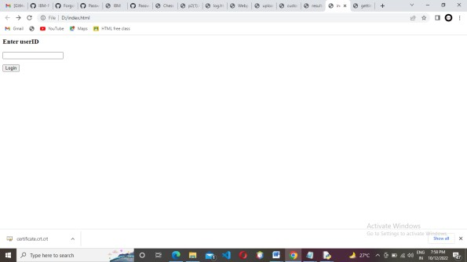

**QUESTION 4:** Session page

#### PROGRAM

Session.py

from flask import * app = Flask( name ) app.secret_key = "abc"

@app.route('/') def home():

res = make_response("<h4>session variable is set, <a href='/get'>Get Variable</a></h4>") session['response']='session#1'

return res;

@app.route('/get') def getVariable():

if 'response' in session:

s = session['response'];

return render_template('getsession.html',name = s)

if name == ' main ': app.run(debug = True)

getsession.html

<html>

<head>

<title>getting the session</title>

</head>

<body>

<p>The session is set with value: <strong>{{name}}</strong></p>

</body>

</html>

##### OUTPUT:

